## Lists

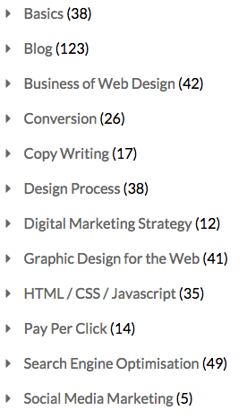Lists are very common around the web. Some pictures displayed below of what unstyled and styled lists look like are below.

Figure Styled list

Figure Unstyled lists

There are two kinds of lists an ordered kind and an unordered kind. The ordered kind keeps track of list items and numbers each item in the list, while the unordered uses bullet points for each item. More information can be found here on lists: <http://www.w3schools.com/html/html_lists.asp>

Figure 2Unstyled lists

**Basic list tags**

**<ul></ul>** an unordered list

**<ol></ol>** an ordered list

**<li></li>** a list element

When creating lists you would choose either a <ul></ul> or <ol></ol> tag and then simply include <li></li> tags within those tags with list item content. For example:

<ul>

<li>Dogs</li>

<li>Cats</li>

</ul>

Later on after covering CSS we will learn how to remove those bullet points and numbering on these lists to make them look nicer.

Task 1:

1. Try create a basic unordered list with three list items inside.
2. Then convert this unordered list to an ordered list preserving the items.
3. And lastly using the link provided above convert your ordered list to a description list adding additional description tags for each of the three elements you had previously.

Remember to keep checking your changes when doing the task above either if using CodePen to write HTML or loading your file in your browser to see what turns up on your page.